42 Wallaby Way Montreal, QC H3Y 8Y3

***Thorsten Ewald***

*2020-03-27 18:21:00*

--------------------------------------------

State your recommendation here, as well as the costs and timeline. This is a courtesy document for the primary reader; give them the main findings and recommendation – very briefly

March 19, 2020

Thorsten Ewald Instructor

3700 Willingdon Avenue, SW2-257 Burnaby, BC V5G 3H2

#### Implementation of RoVaPaste 3D Food Printers in Hopsitals

Dear Thorsten,

Please accept this proposal for the implementation of RoVaPaste 3D food printers - which not only improve the nutrition for patients, but also reduce food waste and save resources - at your facilities.

Hospitals are known worldwide for offering food services that lack quality and meals that are not appealing or tasty. This leads to many problems, not only for patients, but for the hospital as well. We are also aware of the current COVID-19 situation, how it has affected your facilities and how it aggravates those issues, so we hope that this proposal clearly states the problems and how they can be solved by the proposed project.

The proposal starts by covering the problems that the hospital currently faces, and then goes on to explain the details about the technology we are introducing, how the hospital would benefit from this investment, what the implementation schedule would be, the information related to costs and budget, our evaluations and conclusions and, finally, our recommendations for implementation.

We hope you enjoy reading the report. Please feel free to contact us with any questions you may have about the content. We look forward to seeing the changes and benefits for the hospital if the project is approved.

Yours truly,

[Team lead’s name here]



0

PROPOSED IMPLEMENTATION OF ROVAPASTE 3D FOOD PRINTERS IN HOSPITALS

Submitted By:

Grace B. Jeffry T. Vitoria M.

Submitted on: March 19, 2020

Table of Contents

Summary 1

Introduction 2

Problems 2

Malnutrition 2

Food Waste 3

Required Resources 3

Solution 3

Proposal Details 4

Technology 4

Benefits 4

Improve Nutrition 4

Reduce Food Waste 6

Save Resources 6

Implementation Schedule 7

Phase l: Planning and Testing Site Selection 7

Phase ll: One Ward Implementation 7

Phase lll: Entire Hospital Implementation 7

Phase lV: Regional Implementation 8

Costs and Budget 9

Evaluations 9

Conclusions 10

Recommendations 10

References 11

Appendices 13

Appendix A - RoVaPaste 3D Food Printer Specifications 13

Appendix B - Cost Breakdown of Average Food Waste 14

Appendix C - Average Wage for Printer Implementation 15

List of Figures

Figure 1 - Examples of 3D Printed Food 5

Figure 2 - Gantt Chart for Implementation of RoVaPaste 3D Food Printers in Hospitals 8

Figure 3 - RoVaPaste Specifications 13

Figure 4 - Machine Set Up Operator Hourly 15

List of Tables

Table 1 - Cost Breakdown of Required RoVaPaste Machinery and Installation Per Hospital 9

Table 2 - Derived Calculations of Average Food Waste at VGH for Three-Months 14

# Summary

If you have ever been to or visited others at a hospital, I’m sure you have come across the disappointment that is hospital food. Hospital food is largely unappetizing, un-customizable and does not meet patient satisfaction, leading to low food intake levels. This contributes to malnutrition and food waste evident in studies done at hospitals around the world. Furthermore, this decreases the efficiency and optimization of the resources that hospitals invest in their food services and overall budget.

The implementation of RoVaPaste 3D food printers in hospitals would reduce malnutrition, reduce food waste and save resources. The printers would improve the customizability, portion control, appeal and nutritional value of food, which would altogether increase the food intake levels and reduce malnutrition. Along with the general patient population, this would exponentially benefit those who require texture-modified diets and children.

The increase in intake levels directly leads to a reduction in food waste, saving food costs for the hospital. Additionally, the 3D printer does not require large maintenance fees, set-up times, or a variety of skilled workers; therefore, it optimizes the resources and provides more budget for the hospital to spend towards other facets.

The implementation will occur in four phases over nine months. Phase I is planning and selecting a testing site. Phase II, Phase III and Phase IV will take six months altogether. Phase II will start by testing one ward and Phase III will test the entire hospital and finally, Phase IV will be implemented into the entire health authority region. Each phase will have evaluations implemented to ensure the printers are meeting the demand of patients. The evaluation will include acquiring hospital staff observations, conducting patient satisfaction surveys (i.e. food appearance, taste, consistency, and variety) (Mccullough et al., 2017), and measuring food waste.

We recommend implementing the RoVaPaste 3D food printer immediately. In light of recent events with COVID-19, the implementation of the printers into hospitals will help mediate the higher need for food production to meet the increased influx of inpatients in hospitals. In these crucial times, it is important to provide people in need the best possible nutrition and service.

# Introduction

Food plays an important role in the nutritional needs and health of people, especially hospital patients. Patients with a higher risk of malnutrition end up having longer hospital stays and have more postoperative complications (Thomas et al., 2016). Currently, there are several issues with hospital food, such as poor nutrition, food waste and inefficient use of resources.

Studies have found that one in three patients is malnourished during their stay at the hospitals. Yet the hospital kitchens are experiencing high percentages of food waste and labour costs.

Fixing these issues will help hospitals manage their operations and provide more nutritious and appetizing meals; in turn, it can reduce food waste and the required resources.

## Problems

This section outlines the current problems with hospitals’ food services.

### Malnutrition

Malnutrition in hospitals is a worldwide occurrence and is evident in multiple studies. One of the largest multicentre survey studies done in the world was conducted with 3,122 patients from 56 hospitals, in the Australasian region. From this study, Agarwal et al. (2013) concluded that one in three patients were malnourished and two in three patients don’t fully consume their meals.

This is one of many studies that verify the global scale of poor nutrition throughout all hospitals.

Hospital patients don’t receive their full nutritional value from their meals because the food options follow a fixed daily schedule leading to meals being largely un-customizable and unappealing. Since the hospitals’ food menu follows a schedule, certain day’s options may not meet the patient’s liking, or the patient may grow sick of eating that same meal due to a long hospitalization. This makes it hard for staff to balance having a plausible operation while fulfilling a patient’s food needs and preferences.

Although hospitals try to provide food that matches or is above the required daily intake of calories and protein, malnutrition is correlated to low food intake levels (Curtis et al., 2018). One study found that only 28% of their study participants had eaten all of the food they were served, and most patients related their poor intake to the food temperature, appearance, and aroma (Stanga, 2003). Low food intake doesn’t only lead to patient malnutrition but also to higher food waste.

### Food Waste

Food waste is an endemic problem for all hospitals, contributing to health, economic, social and environmental issues. As mentioned above, any food waste by the patient indicates dissatisfaction and has a negative effect on the patient’s nutrition.

Several academic sources have reported that approximately 30-50% of total food placed at a patient’s bedside goes to waste. To put this into perspective, according to Green Health Care (2020), “in 2010, this resulted in $45 million in wasted food, not accounting for service and labour costs to produce and prepare the food itself (Gooch, Chong).” To make matters worse, a study by Alshqaeeq et al. (2017) found that hospital food waste is actually three-fold higher than the patient-tray waste.

There are many factors that contribute to the vast amount of food waste in Canadian hospitals: overproduction, poor food quality, advanced ordering of meals from external sources, scheduled meal deliveries, lack of an alternative for dietary restrictions and un-customizable meal orders (Schiavone et. al, 2019). Resolving these issues would help reduce the resources, time and money hospitals spend on food services. Additionally, this would greatly improve food sustainability, as many resources (i.e. the necessity of agricultural land, chemicals, GHG emissions required to transport food and irrigation water) will ultimately be saved by the hospital.

### Required Resources

A large issue in hospitals is the time and resources required to make food that is ultimately not fully consumed, which leads to malnutrition and food waste. A report by Murphy (2017) found that labour costs account for 70% of a food services budget with the rest going to supplies, including food. Hospitals operate under limited budgets, and, many times, costs are cut from departments that don’t directly contribute to patient care. This often leads to neglect and underfunding for the food services department, creating a need for hospitals to be more efficient and creative with their resources while improving patient health.

## Solution

For hospitals to prevent malnutrition, reduce food waste, and save resources that are required for their food services, we propose the implementation of RoVaPaste 3D food printers in hospitals.

# Proposal Details

Based on hospitals’ current food services system and effectiveness, we suggest the implementation of the RoVaPaste 3D food printer.

## Technology

The RoVaPaste 3D food printer is professional equipment that can print almost any paste-type or liquid material (“RoVaPaste + Filament 3D Printer,” n.d.), enabling kitchen staff to feed the machine with nutritious and good-tasting pastes that can be produced in-house. All the specifications used in this proposal have been retrieved from RoVaPaste 3D food printer product information and the full specifications can be seen in Appendix A.

The RoVaPaste provides many different modes of printing. Some of the most useful ones for the hospital would be:

* Single Paste, which prints with one material,
* Dual Paste, which prints with two materials, and
* Ultrafast Printing, which prints a large quantity of food in a short amount of time.

Other modes include Epic Resolution, which allows for more details and smoother surfaces; dual extruder, which enables dissolvable support, as well as printing two identical objects at the same time. The results look surprisingly appetizing (See Figure 1).

The maximum print dimensions (11.18” x 11.88” x 7.55”) also fit very well with the type of production it would be used for (individual meal platters).

## Benefits

The following describes the benefits of the RoVaPaste 3D food printer in addressing the problems stated above.

Improved Nutrition

RoVaPaste 3D food printers can help decrease malnutrition in hospitals by allowing for more customizable, portion-controlled, aesthetically appealing, and nutritionally dense food. The printers provide more customizability to meals because they can produce a large variety of foods using any combination of pastes. Dual Paste mode can provide food items with a multitude of colours and can be shaped into any form. Figure 1 below shows the variety of possible meals you could create using a 3D food printer, and how closely they resemble real meals.

This would be especially appealing to children since food can be shaped like dinosaurs or flowers, thus making the diet more interesting and more likely to be consumed. Furthermore, medicine can be incorporated into the paste itself, so medical staff can administer medicine more easily through the 3D printed food.

The rate of malnutrition was found to be higher in patients who were prescribed texture-modified diets (TMD) to prevent choking due to these patients having dysphagia, or difficulty chewing(Vucea et al., 2019). TMD resulted in a higher malnutrition rate due to the kitchen’s inability to cook a wide variety of TMD food items with acceptable appearance and taste (Irles Rocamora & García-Luna, 2014). However, by migrating to a 3D food printer system, since the printer would be able to print pastes in any form and shape, the meals would look more similar to the way the patients expect solid food to look, which can be comforting for people that have been limited to a TMD (refer to Figure 1 for visual examples).

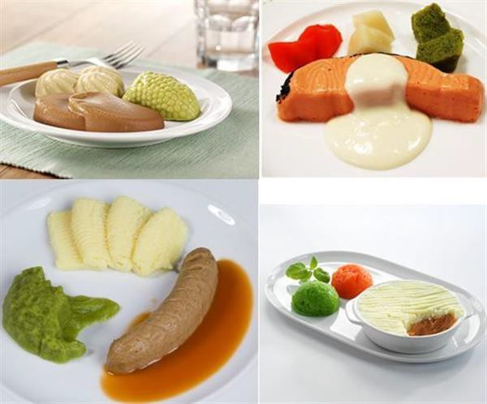

*Figure 1 - Examples of 3D Printed Food*

[*3ders.org - Sweden To Serve 3D Printed Meals To Aged In Care Houses - The Best 3d Print 2020*](https://3dprintingzoom.com/2019/03/06/3ders-org-sweden-to-serve-3d-printed-meals-to-aged-in-care-houses/)

Overall, these above factors would lead patients to eat more and, therefore, have an improvement in their nutrition, as well as satisfaction.

Reduced Food Waste

As mentioned above, various factors contribute to poor nutrition in hospitals and this directly correlates to a large amount of food waste. Firstly, 3D food printers would help reduce food waste by tackling the overproduction of food. They would allows the kitchen staff to produce food according to the demand, in terms of a meal per patient, instead of the current method of cooking large batches of food. Additionally, hospital staff would know how much paste the 3D printers require to produce X amount of food, therefore decreasing the amount of food wastage at the preparation level.

Secondly, 3D food printers help resolve the lack of customizability. Currently, food follows a set schedule and a patient’s meal preferences are largely not met. By using the 3D food printer, you do not have to follow the same fixed meal schedule since paste tubes are easily interchangeable. Instead, the hospital can provide a patient with their most desirable meal, thus increasing their meal consumption and decreasing food waste. The customizability includes making 3D printed food that is more nutritionally dense. This would help deliver the same nutritional benefit to patients who may have a small appetite for various reasons.

Saved Resources

Currently, hospitals need to be more efficient and creative with their resources, as labour costs account for 70% of the budget towards food services, with the rest going to the supplies (Mejia, 2016). 3D food printers are capable of assembling multiple food items at the same time from pastes, reducing the amount of staff required, since tasks like cutting food become obsolete.

Additionally, there is less training and qualifications needed for staff, as the production of the 3D printed food is relatively simple, and the preparation only requires blending the food to make the pastes. The remaining staff can also be more efficiently delegated to work on more tasks once the 3D food printers are set-up.

Modern 3D food printers are a great tool to automate the production of fresh, appealing and adequate amounts of food within the current time constraints, using RoVaPaste’s Ultrafast Printing mode. 3D food printers replace the general food production assembly line, only require an oven or steamer to cook the food if necessary and a small array of equipment to prepare the pastes. Therefore, 3D food printers save not only the labour costs but also the costs of purchasing and maintaining equipment that is no longer necessary.

By solving the food waste problem, RoVaPaste would also save money. In just three months, the hospital would save over $230,000.00 (Appendix B shows the derived calculations based on VCM International’s report done in 2014), which would not only cover the costs of the newly implemented 3D food printers (see Costs and Budget section), but also allow for the hospital to invest in new, fresh and nutritious ingredients that would be used to make the pastes.

# Implementation Schedule

The estimated schedule for this project is nine months and implemented over four phases.

Put the Gantt chart here as a quick, visual overview of the whole process and to provide context for the following subsections.

## Phase l: Planning and Testing Site Selection

In the initial phase, planning and testing site selection, the stakeholder will select their hospital ward of choice for Phase II and Phase III implementations. A 14-day period is suggested to allow enough time for discussion and selection of a testing site. Some example selection criteria may be that Ward X at Hospital X has consistent issues with patient nutrition, a large amount of food waste, or received many recent complaints from patients about their meals.

## Phase ll: One Ward Implementation

Once a testing site is selected, the One Ward Implementation phase will commence. Phase II will proceed over a 30-day time period to ensure the 3D food printer functions at the expected rate and produces foods that are welcomed by the patients. Only the required number of printers will be installed for evaluation, thus causing less disruption to the operation and staff requirement.

The evaluation of Phase II will start on the 15th day, half-way through Phase II. Phase II Evaluation includes determining whether the production rate by the 3D food printers meets the demand of patients, by acquiring hospital staff observations, conducting patient satisfaction surveys (i.e. food appearance, taste, consistency, and variety) (Mccullough et al., 2017), and measuring food waste.

An evaluation of production rate matching or above the rate of demands is a pass, patient satisfaction above 80% and food waste below 30% is a pass.

## Phase lll: Entire Hospital Implementation

Once Phase II is successful, the total number of printers that are required to feed the entire hospital will be installed. More staff will be trained and allocated to managing the printers. Phase III will run for a 90-day period. This phase will provide a larger sample pool for evaluation.

Evaluations will start on day 106, two-months into Phase III, and be completed within a month. The same evaluation will be applied to Phase III as in Phase II and with the same passing criteria.

## Phase lV: Regional Implementation

Moving onto the final phase, Phase IV: Regional Implementation, printers will be installed in all health care facilities within the health authority region. This phase includes scheduled training sessions for staff at each site about operating and performing preliminary troubleshooting for the printer. One evaluation will be done on day 198, two months into Phase IV, to evaluate all sites with the same evaluation and passing criteria as in the previous phases. One additional evaluation is included to ensure staff at each site are knowledgeable and prepared to write? the printer. The evaluation will be complete within a one month.

After Phase IV, all implementation will be complete. Thus, evaluations hereafter will be done through third-party consultants three and six months after implementation.

Figure 2 shows the timeline and breakdown for each phase in the implementation schedule.

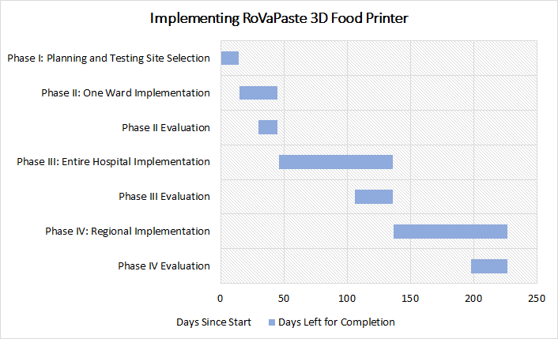

*Figure 2 - Gantt Chart for Implementation of RoVaPaste 3D Food Printers in Hospital**s*

***Thorsten Ewald***

*2020-03-27 19:37:00*

--------------------------------------------

Table titles go above the table.

***Thorsten Ewald***

*2020-03-27 19:38:00*

--------------------------------------------

You’ve already described the evaluation as part of the description of the phases. Direct the reader there.

# Costs and Budget

The following budget, shown in Table 1, is based on average wage expectations for a Machine Set Up Operator (Payscale.com, n.d.) (See Appendix C for details). The calculations in Table 1 also includes a 15% contingency, which will be used to cover unexpected expenses such as overtime work.

Note that if there are any technical problems with the printers, or if the migration to a 3D printer food process does not show improvement in appetite, we will refund the cost of the printers.

|  |  |  |
| --- | --- | --- |
| Expenses | Calculation | Cost (USD) |
| Direct Costs | | |
| RoVaPaste | 10 * 1,999 | 19,990 |
| Estimated shipping | 100 | 100 |
| Indirect Costs | | |
| Installation Labour | 16.19/hr * 5 hours | 80.95 |
| Contingency | Total * 0.15 | 1,526.385 |
| Total Cost | | 21,697.335 |

*Table 1 - Cost Breakdown of Required RoVaPaste Machinery and Installation Per Hospital*

# Evaluations

The impact of the 3D printed food on tackling the problems of poor nutrition, food waste, and resource usage will be evaluated to verify its benefits. As seen in previous studies, the status of nutrition in hospitals and the amount of food waste can be accurately calculated. Our plan is to engage accredited third-party healthcare and research consultants to evaluate the benefit to patients’ health and reduction in food waste in our hospitals. To verify the benefits are not just a short-term solution but long term, we plan to monitor the once at three-month time and another at six-months time.

***Thorsten Ewald***

*2020-03-27 19:39:00*

--------------------------------------------

This is a conclusion.

The savings to the resources, labour and time from our 3D printed food can be determined within our accounting department with the current structure and additional initial audits.

# Conclusions

The implementation of RoVaPaste 3D printers in hospitals would improve the epidemic problem of poor nutrition, food waste, and wasted resources. The printers will be able to improve the aesthetic and customizability of the current food production in hospitals, vastly improving a patient’s satisfaction and their experience towards a hospital. Furthermore, this will increase food intake levels and food nutrition, which reduces patients’ malnutrition and the amount of food waste. Along with the food resources saved, 3D food printers would reduce the time, labor and equipment costs required for food services. Hospital’s food services play a large role in patient's health; 3D food printers would allow for the optimization of limited resources while increasing food quality, service, and patient satisfaction.

# Recommendations

Considering the current COVID-19 pandemic affecting hospitals across the world, we recommend implementing RoVaPaste 3D food printers immediately due to the increased number of patients. Starting with the implementation stages, the printer can start supporting the current food services and then concurrently fully transition into printers producing meals. Lastly, this would reduce the resources required for food services, allowing the hospitals to allocate them towards other operations and better treatment for patients.

# References

Agarwal, E., Ferguson, M., Banks, M., Batterham, M., Bauer, J., Capra, S., & Isenring, E. (2013). Malnutrition and poor food intake are associated with prolonged hospital stay, frequent readmissions, and greater in-hospital mortality: Results from the Nutrition Care Day Survey 2010. Clinical Nutrition, 32(5), 737–745. doi: 10.1016/j.clnu.2012.11.021

Alshqaqeeq, F., Twomey, J., Overcash, M., & Sadkhi, A. (2017). A study of food waste in St.

Francis Hospital. International Journal of Healthcare Management, 1-9. doi: 10.1080/20479700.2017.1414982.

Average Machine Set Up Operator Hourly Pay. (n.d.). Retrieved March 17, 2020, from [https://www.payscale.com/research/US/Job=Machine_Set_Up_Operator/Hourly_Rate](https://www.payscale.com/research/US/Job%3DMachine_Set_Up_Operator/Hourly_Rate)

Curtis, L. J., Valaitis, R., Laur, C., Mcnicholl, T., Nasser, R., & Keller, H. (2018). Low food intake in hospital: patient, institutional, and clinical factors. Applied Physiology, Nutrition, and Metabolism, 43(12), 1239–1246. doi: 10.1139/apnm-2018-0064

Food Waste – Canadian Coalition for Green Health Care. (n.d.). Retrieved March 17, 2020, from <https://greenhealthcare.ca/waste/food-waste/>

Gooch, M.V. and Felfel, A. (2014). “27 Billion Dollars” Revisited- The Cost of Canada’s Annual Food Waste. Value Chain Management International Inc. Retrieved March 17, 2020, from: [http://vcm-international.com/wp-content/uploads/2014/12/Food-Waste-in-](http://vcm-international.com/wp-content/uploads/2014/12/Food-Waste-in-Canada-27-Billion-Revisited-Dec-10-2014.pdf) [Canada-27-Billion-Revisited-Dec-10-2014.pdf](http://vcm-international.com/wp-content/uploads/2014/12/Food-Waste-in-Canada-27-Billion-Revisited-Dec-10-2014.pdf)

Irles Rocamora, J. A., & García-Luna, P. P. (2014). El menú de textura modificada; valor nutricional, digestibilidad y aportación dentro del menú de hospitales y residencias de mayores. Nutricion Hospitalaria, 29(4), 873–879. doi: 10.3305/nh.2014.29.4.7285

Mccullough, J., Marcus, H., & Keller, H. (2017). The mealtime audit tool (MAT) – inter-rater reliability testing of a novel tool for the monitoring and assessment of food intake barriers in acute care hospital patients. The Journal of Nutrition, Health & Aging, 21(9), 962-970. doi:<http://dx.doi.org/10.1007/s12603-017-0890-7>

Mejia, M. L. (2016, February 18). How hospital food budgets affect patients. Retrieved March 16, 2020, from <https://www.tvo.org/article/how-hospital-food-budgets-affect-patients>

Murphy, T. (2017). The Role of Food in Hospitals - A HealthCareCAN Issue Brief. Retrieved from <http://www.healthcarecan.ca/wpcontent/themes/camyno/assets/document/> Reports/2017/HCC/EN/RoleofFood_FinalEN. Pdf

ORD Solutions launches fully assembled RoVa-Paste/Food 3D printer for under $1000CAD. (n.d.). Retrieved March 16, 2020, from https://[www.3ders.org/articles/20140910-ord-](http://www.3ders.org/articles/20140910-ord-) solutions-launches-fully-assembled-rova-paste-food-3d-printer.html

RoVaPaste + Filament 3D Printer. (n.d.). Retrieved March 17, 2020, from <https://www.ordsolutions.com/rovapaste-filament-3d-printer/>

Schiavone, S., Pelullo, C. P., & Attena, F. (2019). Patient Evaluation of Food Waste in Three Hospitals in Southern Italy. *International journal of environmental research and public health*, *16*(22), 4330. <https://doi.org/10.3390/ijerph16224330>

Stanga, Z. (2003). Hospital food: a survey of patients perceptions. Clinical Nutrition, 22(3), 241– 246. doi: 10.1016/s0261-5614(02)00205-4

Thomas, M. N., Kufeldt, J., Kisser, U., Hornung, H.-M., Hoffmann, J., Andraschko, M., … Rittler, P. (2016). Effects of malnutrition on complication rates, length of hospital stay, and revenue in elective surgical patients in the G-DRG-system. Nutrition, 32(2), 249– 254. doi: 10.1016/j.nut.2015.08.021

Vucea, V., M.Sc, Keller, Heather H,PhD., R.D., Morrison, J. M., M.Sc, Duizer, L. M., PhD., Duncan, Alison M,PhD., R.D., & Steele, C. M., PhD. (2019). Prevalence and characteristics associated with modified texture food use in long term care: An analysis of making the most of mealtimes (M3) project. Canadian Journal of Dietetic Practice and Research, 80(3), 104-110. doi:<http://dx.doi.org/10.3148/cjdpr-2018-045>

# Appendices

## Appendix A - RoVaPaste 3D Food Printer Specifications

The following poster shows the full technical specification of RoVaPaste 3D Food Printer.

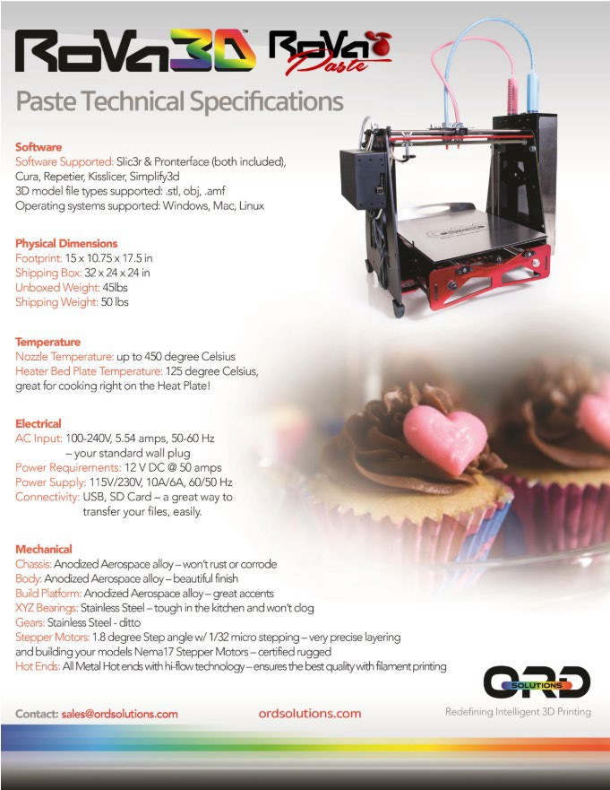

*Figure 3 - RoVaPaste Specifications* [*ordsolutions.com - RoVaPaste + Filament Printer*](https://www.ordsolutions.com/rovapaste-filament-3d-printer/)

## Appendix B - Cost Breakdown of Average Food Waste

The following table shows the costs of meals a hospital can save based on the estimates found by Dr. Gooch and Dr. Felfel from Value Chain Management International Inc. (2014).

|  |  |
| --- | --- |
| Average food cost per patient per day | $1.50 |
| Vancouver General Hospital (VGH) Occupancy per day* assuming 90% occupancy rate | 1710 people |
| Average cost of food for VGH per day | $2565 |
| Average cost of food for VGH over three- months | $230,850 |

*Table 2 - Derived Calculations of Average Food Waste at VGH for Three-Months*

## Appendix C - Average Wage for Printer Implementation

The following chart show’s Payscale’s average hourly pay of a Machine Set Up Operator (“Average Machine Set Up Operator Hourly Pay,” n.d.).

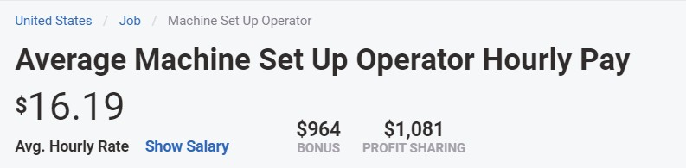

*Figure 4 - Machine Set Up Operator Hourly Pay*

[*payscale.com – Average Machine Set Up Operator Hourly Pay*](https://www.payscale.com/research/US/Job%3DMachine_Set_Up_Operator/Hourly_Rate)